**Applicability of digital tools for learning: Determining the usability of digital tools for education**

Simon IHegbu, Soher Alghibar, Shahzad Babar, Peilin li, and waqas gul (group 20)

Abstract: The abstract should not exceed more than 150 words. It should include answers to following questions: What is the context? What is the question(s) you investigated? What were the research design/strategy and methods used? What are the major findings?

Nowadays, it is common to use digital tools for learning purpose. Digital tools can promote innovation, learning, and student engagement; and can offer specific opportunities for the promotion of student learning outside the classroom. The research question for this study is do digital tools affect the students’ learning outcome? This study also investigates if whether there is any association between average students’ grades and digital tools usage like text production, audio production, video production and image production. With the survey strategy, it applies quantitative approach using questionnaire questions for data collection. This research is conducted on students of DSV in Stockholm University. The result shows that the usability index of digital tools is 65.9425, and that, overall, there is no significant association between Average grades of the students and Digital tools usage.

Key Words and Phrases: List key words and phrases here in the order of relevance - separated by semicolons;

# INTRODUCTION (1 page)

An introduction should establish the context of the work being reported. This is accomplished by summarizing the current understanding of the problem you are investigating. The introduction should make the reader understand what the paper is about and make the reader interested in reading it by answering the questions:

* What is the context?
* What am I studying?
* Why is that an important question?
* What did we know about it before I did this study?
* How will this study advance our knowledge?

Globalization, innovative digital technologies and multimedia tools continue to facilities the people to rethink how they communicate. These technologies usher new teaching and learning environments as well as trigger a different kind of relationship between the instructor and the learner (Beetham & Sharpe, 2013). Digital learning is any type of learning that is accompanied by technology or by instructional practice that makes effective use of technology. It refers to anything that involves technology in education. This includes devices and means of communication such as computers, tablets, smartphones, interactive whiteboards and broadband and Wi-Fi, but also software such as educational games and digital learning tools and all educational applications that can be found on the Internet (Haelermans, 2017). In general, the usage of digital tools in learning seems to be more effective where it is increasing knowledge regarding which digital applications in education are effective. It is also creating common support for using ICT in education among those that actually have to use the digital tools. The effectiveness of digital tools in education is primarily dependent upon the way digital tools is implemented, as well as on the types of learning for which ICT in education is used. Furthermore, it is important that school leaders and teachers see the benefits of digital tools and are confident in using it. Simply having access to digital tools in education will not necessarily lead to its effective use, and might even lead to negative results if digital tools is merely a distraction and not applied in an effective way (Haelermans, 2017).

In this paper, we will address digital tools in terms of their applications in DSV, Stockholm University to improve the effectiveness of the teaching and learning process.

Usability Index, (also, Performance Index) is the mean of the scores expressed as a percentage which estimates how well, e.g. web page(s), shopping platform(s), etc., performs (Hsu, 2008; Mundle, Zhao, & Bangalore, 2004; Rempel, 2015). Similarly, in this study, usability of digital tools estimates how usable are digital tools with regards to learning. (i.e. how well has digital tools performed in terms of likeability, accessibility, and acceptability by the students.

## Research problem

The way we communicate, and make meaning has changed, and there is a need to adopt the contemporary approach of communication in terms of writing and making images (Digital writing tools from the student perspective: Access, affordances, and agency.2019, p. 1563), Many Universities nowadays are adopting the so-called e-learning, distance education, distance courses for education delivery. These methods of learning require extensive ICT usage for communication between the learners and the instructors (More & Kearsley, 2012; Simonson, Smaldino, & Zvacek, 2015). The number of participants in distance learning has drastically increased (Bagriacik Yilmaz, 2019) which is to the advantage of both learner and educator. From the instructor point of view, the usage of digital tools is expected to add value to the way education is delivered, especially in the dynamic world of digital age. Thus, digital tools are supposed to support e-learning in terms of writing, image making and video productions, etc. From the students' perspective, e-learning is, in no small extent, ICT dependent. Students (both conventional and distance learners) need to catch up with the new developments in communication and need to learn effectively. Therefore, utilizing digital tools would nonetheless make students learn differently. With regards to learning, students need to be aware of the accessibility, affordability, and the employability of digital tools (Digital writing tools from the student perspective: Access, affordances, and agency.2019; Ali, Murphy, & Nadkarni, 2014). In terms of accessibility, affordability and usability, the study by (Digital writing tools from the student perspective: Access, affordances, and agency.2019) indicates that research is lacking in terms of understanding the contemporary multimodal approach of digital tools with regards to how we make meaning (writing, imaging, and video production). Therefore, this study and the knowledge it produces will help instructors and students access the resources of digital tools to their advantage, particularly during learning.

Similarly, the study conducted by (Ali et al., 2014) regarding students’ perception of digital tools for learning, using focus group, indicated that the sample size was too small, therefore, recommended a more extensive study. Since the sample size of this study is more significant, thus, this study will overcome the limitations recorded in (Ali et al., 2014). The problem which this study addresses is a practical problem because empirical data is involved. However, to ensure that this study follows proper scientific pattern, scientific literature is extensively applied to support and make sense of the primary data. For example, the problem formulation, data collection method, data analysis and presentation of the result have followed from the scientific literature. Problem explication is the first thing to do in design science (Johannesson & Perjons, 2012, p. 51). Similarly, Randolph indicated that the research problem should justify the need for conducting a research (Randolph, 2008, pp. 17-18).

## Research question

Research Question: Do digital tools affect our learning outcome?

SQ1. What is the usability index of digital tools?

SQ2. Is there any association between student’s performance and the use of digital tools for learning?

Having determined the usability index of the digital tools. This study responds to the second sub-question by formulating the following hypothesis.

H0: There is an association between the Average grades of students and digital tools usage.

Ha: There is no association between Average grades of students and digital tools usage.

If an association exists, how stochastically significant it is? Or is the association by chance alone?

# METHODOLOGY (0,5-1 page)

* State what statistical tests you have performed and why.
* Discuss handling of extreme values and missing values beyond just dropping them from the analysis (marking them 999).

Participants are students from the Course MMII VT2019, in total of 196 students only 99 participated in the email survey, which was sent as a link attached to the email from the course instructor. Their answers initially constituted the data set. The questionnaire answers were given beforehand from the instructions.

The questionnaire was divided into 4 categories (i.e. A, B C, D). During the data analysis, we picked one question (i.e. what is your average grade off all the courses that you have completed?) from the first category which represented that group. We then picked 4 questions from category C, namely, on a scale of 0-100 how useful is this (production of text) for your learning process? On a scale of 0-100 how useful is this (production of audio) for your learning process? On a scale of 0-100 how useful is this (production of video) for your learning process? And, on a scale of 0-100 how useful is this (production of images) for your learning process? The rest of the categories do not apply to our study. We think that the 5 questions altogether, are the best questions that we can analyze to respond to our research questions

Cleaning up the data

We cleaned up the dataset by deleting the questions that do not apply (or are irrelevant to our study). There was a total of 48 questions. The trimming down of the dataset resulted to 5 questions (variables). Using the menu, transform, (->System-missing) in the SPSS, the missing values were replaced with -1 so that SPSS does not include missing codes in the computation of values.

# RESULTS AND FINDINGS (4-5 pages)

* Present descriptive statistics that provides the reader with an overview.
* Present the statistical tests and perform an analysis that will answer the research question/s. Construct clear and meaningful tables and figures (edit the output from SPSS in e.g. Excel). Present results in accordance with standards for how quantitative results should be presented. For instance, T-test results are presented in a standard manner, as are the other test results.
* All tables, figures, charts etc. included in the results section must have titles and captions as well as being referenced in the text.

**Figure 1**

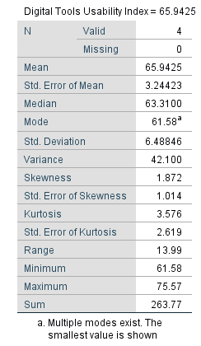

The study performed by (Hsu, 2008) computed the mean of the scores to be the customer satisfaction index (CSI). The same mean was compared to the score determined in the American Customer Satisfaction Index (ACSI., 2019). Similarly, the study performed by (Mundle et al., 2004) calculated the mean of the scores as the performance index of the web pages. Therefore, in this study, we determined the mean (65.9425) of the scores (variables) as the usability index of digital tools Figure 1 above. However, we will perform various statistical tests to buttress our hypothesis.

Descriptive statistics

The descriptive statistics includes, the frequency tables for the 5 variables, histogram for the 5 variables and bar charts for the 5 variables, as shown in (Appendix B below).

Correlation test

We tested if there is a correlation between each of the four variables namely, (Text production, Audio production, Video production, Image production) and Average grade of the students. We also tested if there is correlation in-between the four variables to check for multicollinearity. But before computing the correlations, we first conducted the scatterplots between each of the four variable and the Average grade of student, and between the 4 variables themselves. Due to limited space, only 5 scatterplots are shown. The scatterplots show that there seems to be no good collinearity between the four variables and the Average grade of students, with the exception of “Average grade of students vs. Image production” that showed strong collinearity. We then tested for collinearity in-between the 4 variables (i.e. Text vs. Audio, Text vs. Video, Text vs. Image, Audio vs. Video, Audio vs. Image, and Video vs. Image). There exists some level of collinearity in-between them with Text production vs. Image production showing the strongest bond between each other. We then test for correlation between Average grade vs. Image production. We further hypothesize a Null and Alternative hypothesis as follows,

H0: There is an association between Average grade of the students and digital image production for learning.

Ha: There is no association between Average grade of the students and digital image production for learning.

The correlation test showed that, there exist a negative correlation of .074. Since correlation is between -1 and +1, the data therefore, fails to reject the Null hypothesis. More so, since the correlation significant value is .548 which is greater than p-value of .05, therefore, the association that exist is not stochastically significant. It just occurred by chance. (See Appendix D).

(One reference is needed here)

The Chi-square tests

Although some variations do exist among variables, is the variation due to chance alone or beyond what we would expect? (reference is needed here). How can Chi-square tests help us rule out variation due to chance alone? Chi-square addresses this kind of questions. It is a test of independent between variables.

Our Null and Alternative hypothesis are:

H0: There is a relationship between Average grades of students and Image production for learning

Ha: There is no relationship between Average grades of students and Image production for learning.

p-value = 0.000, alpha level = 0.05

Remember, Average grade of students vs. Image production is the best pair among all the variables pairwise in terms of collinearity, correlation, etc. (See scatterplots, Appendix C below). The Chi-square p-value is .998, which is stochastically insignificant. This shows that both variables are independent. We then reject the Null hypothesis and adopt the alternative that, there is no relationship between Average students’ grade and Image production. The relationship we noticed earlier in correlation occurred just by chance alone (See Appendix D).

Independent sample T-test

This test examines if two variables are different from each other. We then employ our best pair variables, Average students’ grade vs. image production.

ANOVA

Multiple Regression Analysis

# DISCUSSION (1-2 pages)

* Reflect on the research carried out and discuss its contributions in relation to the research question.
* Outline the practical and theoretical significance of the contributions and discuss ethical and social aspects.

In terms of the practical contribution of this research, this study finds that, even though students use digital tools during learning, the usage of digital tools does not positively correlate with the performance of students in terms of their overall grades. That is, with limited exposure to digital tool, students can still do well with their average grades as validated by the negative correlation coefficient of -0.064. In terms of theoretical contributions, since this study is the first toward determining usability index of digital tools as well investigating whether there is an association between students performance and digital tools usage, this study therefore contributes to the scientific literature in its own area.

Ethical and social aspects of this research were ensured by attaching informed consent form in the questionnaire in which participants had to agree or decline their consent. Issues covered in the consent form as discussed by Bhattacherjee (2012) includes, voluntary participation and harmness, anonymity and confidentiality, disclosure, analyzing and reporting, etc.

* Identify limitations in the study and discuss them, e.g. in terms of validity, reliability, generalizability, transferability, and confirmability.

A major limitation of this study is the missing values in the dataset. Although a treatment, imputation (Bhattacherjee, 2012, p. 120), was administered in line with the functionality of SPSS software, we think that the missing value could have affected the determined scores, however not in all aspects. A significant missing values were noticed especially in the variables Audio production and Video production. In terms of reliability, which is a measure to which a construct is consistent or dependable (Bhattacherjee, 2012, p. 56), we be believe that our construct is reliable since a technique which involves different degrees of measurement has been employed. Thus, if this study is repeated multiple times, the same result would be achieved with the usability index slightly shifting higher or lower. In terms of validity, this study has measured what ought to have been measured using the right metrics and method (Bhattacherjee, 2012, p. 58). In terms of generalizability, we think that the result can be generalized over the population, e.g. the sample size of 99 of 196 is quite significant, and sound methodology has been applied. Regarding transferability and confirmability, we think that this study has followed sound scientific method, therefore it can be replicated. This study can be repeated by another person, thus, the result can be confirmed (Krefting, 1991).

The main objective of this research is to analyze and quantify the digital tools effects on the students’ learning outcome. That is, to calculate the usability index of digital tools and to check whether there is any association between students’ performance and the use of digital tools. Different statistical test are performed to check the effects of digital tools on students learning. The first Sub-Question (SQ1) of this research is, what is the usability index of digital tools? Usability index of digital tools is calculated with the help of descriptive statistics and it is 65.9425. The second SQ is, is there any association between students’ performance and the use of digital tools? The Independent T test, and other tests, were performed. the results show that the p-values in most tests is .000 which is less than the alpha value of .05 Thus, the Null hypothesis of this research is rejected in favor of the Alternate hypothesis that, there is no statistical connection between Average grades of students vs. Digital tools usage.

Usability index of Digital tools is measured by descriptive statistical analysis by calculating the mean score of 4 variables of digital tool usage for learning.

The relation between digital tools usage and Average students grades is studied by statistical correlation tests. Average student grades are tested against Text production, Audio production, Video production, and Image production. The most strong negative relationship is discovered between Average grade of students vs. Text production. The overall tests show that there is no significant association between Average grades of the students and Digital tools usage. To check that variation between variables is real or by chance, Chi Square statistical test is performed, and it validated that, No statistically significant relationship exists between average grades of student and digital tools usage.

4.3 Limitations of the study

Due to the insignificance of part of the survey questions relative to the study, only five variables were chosen that are relevant to the research problem, such as the question “ What is your average off all the courses that you have completed?” and rest of four relating to the degree of measure in the production of learning instrument i.e. text, image, audio, and video. The study deepened our measure of the production form of the learning, the relation of image production and students’ average grade performance does not have significant correlation as indicated in scatter plot (see appendix C), in addition, further studies with Chi-square (see appendix D) shows that association between the variables happened to be purely coincidence.

In the study, there occurred inherent limitation in the study methods chosen, of both the survey relied on self-report, which ambiguously allowed participants to answer or not to answer survey questions, with honest input or may not have good insight of their regular behavior resulting not answering questions in details (Schuman, H., & Presser, S., 1996). Contrasting to the recent research on the field of using five prominent learning styles to reinforce positive student academic results and presented the theories one which of using one or more learning instruments with use of matching activities of learning would influence the higher gpa between students (Hawk, T.F. & Shah, A.J., 2007). In this study we have Multiple regression… results blabalbal considering the limitation of time. Neverthless,

The extreme values or missing values is inevitable among empirical data set. As the result, the problem encountered may be prevented in an earlier stage before initial data collecting process. While doing the data entry with statistical programs such as SPSS software it is required to denote the missing value with a specific numeric values proposed such as -1 or 999. We didn’t do listwise deletion which means to drop out missing values from the table, because it may shrink the sample size therefore the small defects may not be noticed. The SPSS software program was used to impute missing values with -1. (Bhattacharjee, 2012)

# Conclusions (0,5 PAGES)

* Draw conclusions from the results and the analysis that answers your research questions.
* Summarize the contributions.
* Suggest areas for future research.

The aim of this paper was to clarify the effects of the digital tools on the students learning outcome and calculate usability index of the digital tools to check whether there is any association between student performance and the use of digital tools or not. This quantitative research assessed that there is no correspondence between Average grades of students and digital tools usage, hence, the Null hypothesis of this research is rejected. Usability index of digital tools is measured by descriptive statistical analysis by calculating 4 variables means and the score of the four variables means is 65. 9425 for the digital usage of learning.

The correlation between digital tools and average students grades is tested and overall tests show that there is no significant association between average grades of the students and digital tools usage. Moreover, chi square is performed to check the variation between variables weather it is real or by chance. The results shows that p-value is .808, which means both variables are independent and there is no significant difference between average grades of student and digital usage.

In future research, it would be better to find variables which can strongly correlate with the digital tools in order to make better methods for learning patterns for distance learning. We need quantitative evaluation of success in learning.

# SOME NOTES ON FORMATTING and SUMBISSIONS

Hard page limit is 8 pages. All body text in the font size 11 (style: normal). Paragraphs are separated by a line break and tabulation as follows.

New paragraph starts here. If bullet points are used they should be separated from the paragraph with an empty line before and after the bullets, like this:

* Bullet point 1
* Bullet point 2
* Bullet point 3

Citations in the running text and the reference list must consistently follow a well-known reference standard - in this case Harvard. If you are referring to the whole publication refer to the text as (Denscombe, 2014) or Clarke & Braun (2006). If you refer to a special section of a publication you need to add page numbers, i.e. (Denscombe, 2014, p. 276) or (Denscombe, 2014, pp. 276-277). See further instructions in [this guide](http://libweb.anglia.ac.uk/referencing/files/Harvard_referencing_2016.pdf).

If you copy text from another document with different formatting and paste it here use, then use **Shift + Option + Command + V** (using Mac) to paste without formatting (as plain text). The inserted text will automatically use the paper formatting. The Chrome shortcut from Windows is the same: **Command + Shift + Option + V**. You can install the extensions if you want. In recent versions of Linux, you can use **CTRL + Shift + V** to paste text without formatting.

Create a *PDF* when submitting the draft and the final version. Name the document solely with your group number (e.g. 01, 04, 11).

**REFERENCES**

Braun, V., & Clarke, V. (2006). Using thematic analysis in psychology. *Qualitative Research in Psychology*, *3*(2), pp. 77-101.

Denscombe, M. (2014). *The Good Research Guide: For Small-Scale Social Research Projects* (5th edition). Open University Press.

Schuman, H., & Presser, S. (1996). Questions and answers in attitude surveys: Experiments on question form, wording, and context. Sage.

Bhattacherjee, A. (2012) "Social Science Research: Principles, Methods, and Practices". USF Tampa Bay Open Access Textbooks Collection. Book 3. htp://scholarcommons.usf.edu/oa_textbooks/3

Hawk, T.F, & Shah, A. J. (2007). Using learning style instrument to Enhance student learning. Decision Sciences Journal of Innovative Education/ volume 5, Issue 1. Available online: <https://doi.org/10.1111/j.1540-4609.2007.00125.x> 1.6.2019.

**APPENDIX A: Division of work**

Explain shortly how the work with each part has been divided between the group members.

**APPENDIX B: FREQUENCY TABLE**

**FREQUENCY TABLE**

|  |  |  |  |  |  |  |
| --- | --- | --- | --- | --- | --- | --- |
| **Statistics** | | | | | | |
|  | | What is your average grade of all the courses that you have completed? | Text production: On a scale of 0-100 how useful is this (production of text) for your learning process? | Audio production: On a scale of 0-100 how useful is this (production of audio) for your learning process? | Video production: On a scale of 0-100 how useful is this (production of video) for your learning process? | Image production: On a scale of 0-100 how useful is this (production of images) for your learning process? |
| N | Valid | 99 | 70 | 24 | 12 | 69 |
| Missing | 0 | 29 | 75 | 87 | 30 |
| Mean | | 4.74 | 75.57 | 62.71 | 61.58 | 77.46 |
| Std. Error of Mean | | .105 | 2.629 | 5.181 | 8.379 | 13.853 |
| Median | | 5.00 | 80.00 | 65.00 | 69.00 | 70.00 |
| Mode | | 5 | 100 | 50 | 76 | 80 |
| Std. Deviation | | 1.046 | 21.999 | 25.383 | 29.025 | 115.069 |
| Variance | | 1.094 | 483.959 | 644.303 | 842.447 | 13240.841 |
| Range | | 6 | 85 | 90 | 84 | 994 |
| Minimum | | 1 | 15 | 10 | 16 | 5 |
| Maximum | | 7 | 100 | 100 | 100 | 999 |
| Sum | | 469 | 5290 | 1505 | 739 | 5345 |

|  |  |  |  |  |  |
| --- | --- | --- | --- | --- | --- |
| **What is your average grade of all the courses that you have completed?** | | | | | |
|  | | Frequency | Percent | Valid Percent | Cumulative Percent |
| Valid | F | 1 | 1.0 | 1.0 | 1.0 |
| E | 1 | 1.0 | 1.0 | 2.0 |
| D | 4 | 4.0 | 4.0 | 6.1 |
| C | 36 | 36.4 | 36.4 | 42.4 |
| B | 38 | 38.4 | 38.4 | 80.8 |
| A | 13 | 13.1 | 13.1 | 93.9 |
| I don't want to answer | 6 | 6.1 | 6.1 | 100.0 |
| Total | 99 | 100.0 | 100.0 |  |

|  |  |  |  |  |  |
| --- | --- | --- | --- | --- | --- |
| **Text production: On a scale of 0-100 how useful is this (production of text) for your learning process?** | | | | | |
|  | | Frequency | Percent | Valid Percent | Cumulative Percent |
| Valid | 15 | 1 | 1.0 | 1.4 | 1.4 |
| 20 | 1 | 1.0 | 1.4 | 2.9 |
| 25 | 1 | 1.0 | 1.4 | 4.3 |
| 29 | 1 | 1.0 | 1.4 | 5.7 |
| 35 | 1 | 1.0 | 1.4 | 7.1 |
| 40 | 2 | 2.0 | 2.9 | 10.0 |
| 47 | 1 | 1.0 | 1.4 | 11.4 |
| 49 | 1 | 1.0 | 1.4 | 12.9 |
| 50 | 3 | 3.0 | 4.3 | 17.1 |
| 53 | 1 | 1.0 | 1.4 | 18.6 |
| 54 | 1 | 1.0 | 1.4 | 20.0 |
| 60 | 3 | 3.0 | 4.3 | 24.3 |
| 61 | 1 | 1.0 | 1.4 | 25.7 |
| 69 | 1 | 1.0 | 1.4 | 27.1 |
| 70 | 6 | 6.1 | 8.6 | 35.7 |
| 74 | 1 | 1.0 | 1.4 | 37.1 |
| 75 | 6 | 6.1 | 8.6 | 45.7 |
| 76 | 1 | 1.0 | 1.4 | 47.1 |
| 79 | 1 | 1.0 | 1.4 | 48.6 |
| 80 | 5 | 5.1 | 7.1 | 55.7 |
| 83 | 1 | 1.0 | 1.4 | 57.1 |
| 84 | 1 | 1.0 | 1.4 | 58.6 |
| 85 | 2 | 2.0 | 2.9 | 61.4 |
| 87 | 1 | 1.0 | 1.4 | 62.9 |
| 88 | 3 | 3.0 | 4.3 | 67.1 |
| 90 | 3 | 3.0 | 4.3 | 71.4 |
| 93 | 2 | 2.0 | 2.9 | 74.3 |
| 94 | 1 | 1.0 | 1.4 | 75.7 |
| 95 | 2 | 2.0 | 2.9 | 78.6 |
| 97 | 1 | 1.0 | 1.4 | 80.0 |
| 99 | 1 | 1.0 | 1.4 | 81.4 |
| 100 | 13 | 13.1 | 18.6 | 100.0 |
| Total | 70 | 70.7 | 100.0 |  |
| Missing | -1 | 29 | 29.3 |  |  |
| Total | | 99 | 100.0 |  |  |

|  |  |  |  |  |  |
| --- | --- | --- | --- | --- | --- |
| **Audio production: On a scale of 0-100 how useful is this (production of audio) for your learning process?** | | | | | |
|  | | Frequency | Percent | Valid Percent | Cumulative Percent |
| Valid | 10 | 1 | 1.0 | 4.2 | 4.2 |
| 24 | 1 | 1.0 | 4.2 | 8.3 |
| 25 | 1 | 1.0 | 4.2 | 12.5 |
| 30 | 1 | 1.0 | 4.2 | 16.7 |
| 35 | 1 | 1.0 | 4.2 | 20.8 |
| 50 | 4 | 4.0 | 16.7 | 37.5 |
| 55 | 1 | 1.0 | 4.2 | 41.7 |
| 57 | 1 | 1.0 | 4.2 | 45.8 |
| 60 | 1 | 1.0 | 4.2 | 50.0 |
| 70 | 1 | 1.0 | 4.2 | 54.2 |
| 71 | 1 | 1.0 | 4.2 | 58.3 |
| 75 | 1 | 1.0 | 4.2 | 62.5 |
| 80 | 3 | 3.0 | 12.5 | 75.0 |
| 84 | 1 | 1.0 | 4.2 | 79.2 |
| 89 | 1 | 1.0 | 4.2 | 83.3 |
| 90 | 1 | 1.0 | 4.2 | 87.5 |
| 94 | 1 | 1.0 | 4.2 | 91.7 |
| 96 | 1 | 1.0 | 4.2 | 95.8 |
| 100 | 1 | 1.0 | 4.2 | 100.0 |
| Total | 24 | 24.2 | 100.0 |  |
| Missing | -1 | 75 | 75.8 |  |  |
| Total | | 99 | 100.0 |  |  |

|  |  |  |  |  |  |
| --- | --- | --- | --- | --- | --- |
| **Video production: On a scale of 0-100 how useful is this (production of video) for your learning process?** | | | | | |
|  | | Frequency | Percent | Valid Percent | Cumulative Percent |
| Valid | 16 | 1 | 1.0 | 8.3 | 8.3 |
| 30 | 1 | 1.0 | 8.3 | 16.7 |
| 32 | 1 | 1.0 | 8.3 | 25.0 |
| 35 | 1 | 1.0 | 8.3 | 33.3 |
| 45 | 1 | 1.0 | 8.3 | 41.7 |
| 65 | 1 | 1.0 | 8.3 | 50.0 |
| 73 | 1 | 1.0 | 8.3 | 58.3 |
| 76 | 2 | 2.0 | 16.7 | 75.0 |
| 95 | 1 | 1.0 | 8.3 | 83.3 |
| 96 | 1 | 1.0 | 8.3 | 91.7 |
| 100 | 1 | 1.0 | 8.3 | 100.0 |
| Total | 12 | 12.1 | 100.0 |  |
| Missing | -1 | 87 | 87.9 |  |  |
| Total | | 99 | 100.0 |  |  |

|  |  |  |  |  |  |
| --- | --- | --- | --- | --- | --- |
| **Image production: On a scale of 0-100 how useful is this (production of images) for your learning process?** | | | | | |
|  | | Frequency | Percent | Valid Percent | Cumulative Percent |
| Valid | 5 | 1 | 1.0 | 1.4 | 1.4 |
| 11 | 1 | 1.0 | 1.4 | 2.9 |
| 18 | 1 | 1.0 | 1.4 | 4.3 |
| 19 | 1 | 1.0 | 1.4 | 5.8 |
| 22 | 1 | 1.0 | 1.4 | 7.2 |
| 25 | 1 | 1.0 | 1.4 | 8.7 |
| 28 | 1 | 1.0 | 1.4 | 10.1 |
| 30 | 3 | 3.0 | 4.3 | 14.5 |
| 36 | 1 | 1.0 | 1.4 | 15.9 |
| 40 | 1 | 1.0 | 1.4 | 17.4 |
| 41 | 2 | 2.0 | 2.9 | 20.3 |
| 48 | 1 | 1.0 | 1.4 | 21.7 |
| 50 | 5 | 5.1 | 7.2 | 29.0 |
| 51 | 1 | 1.0 | 1.4 | 30.4 |
| 52 | 2 | 2.0 | 2.9 | 33.3 |
| 55 | 1 | 1.0 | 1.4 | 34.8 |
| 57 | 1 | 1.0 | 1.4 | 36.2 |
| 59 | 1 | 1.0 | 1.4 | 37.7 |
| 60 | 2 | 2.0 | 2.9 | 40.6 |
| 61 | 1 | 1.0 | 1.4 | 42.0 |
| 65 | 1 | 1.0 | 1.4 | 43.5 |
| 66 | 1 | 1.0 | 1.4 | 44.9 |
| 67 | 1 | 1.0 | 1.4 | 46.4 |
| 68 | 1 | 1.0 | 1.4 | 47.8 |
| 70 | 4 | 4.0 | 5.8 | 53.6 |
| 71 | 1 | 1.0 | 1.4 | 55.1 |
| 73 | 1 | 1.0 | 1.4 | 56.5 |
| 74 | 2 | 2.0 | 2.9 | 59.4 |
| 75 | 3 | 3.0 | 4.3 | 63.8 |
| 78 | 1 | 1.0 | 1.4 | 65.2 |
| 80 | 8 | 8.1 | 11.6 | 76.8 |
| 81 | 3 | 3.0 | 4.3 | 81.2 |
| 85 | 1 | 1.0 | 1.4 | 82.6 |
| 90 | 3 | 3.0 | 4.3 | 87.0 |
| 95 | 2 | 2.0 | 2.9 | 89.9 |
| 96 | 1 | 1.0 | 1.4 | 91.3 |
| 100 | 5 | 5.1 | 7.2 | 98.6 |
| 999 | 1 | 1.0 | 1.4 | 100.0 |
| Total | 69 | 69.7 | 100.0 |  |
| Missing | -1 | 30 | 30.3 |  |  |
| Total | | 99 | 100.0 |  |  |

HISTOGRAM

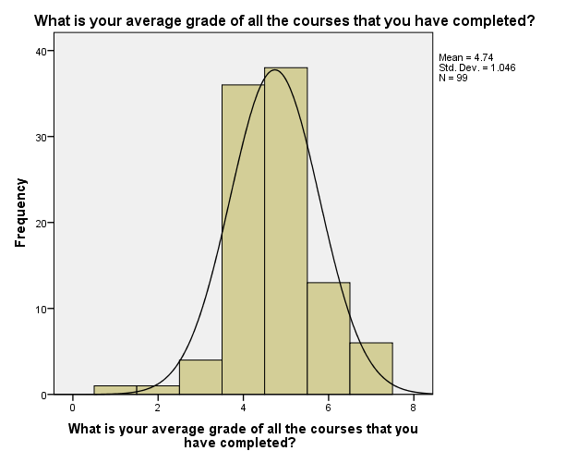

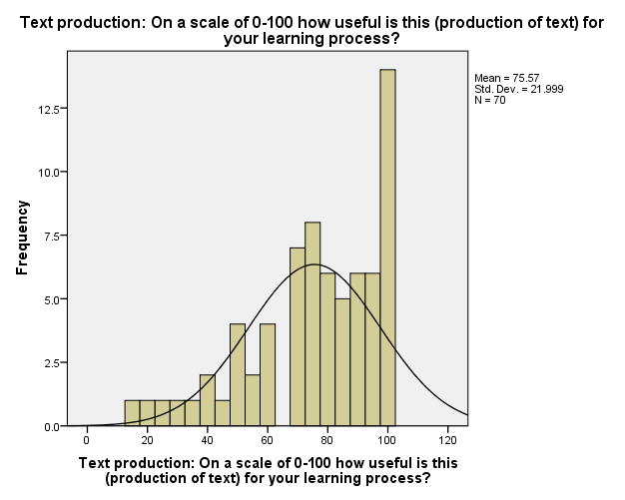

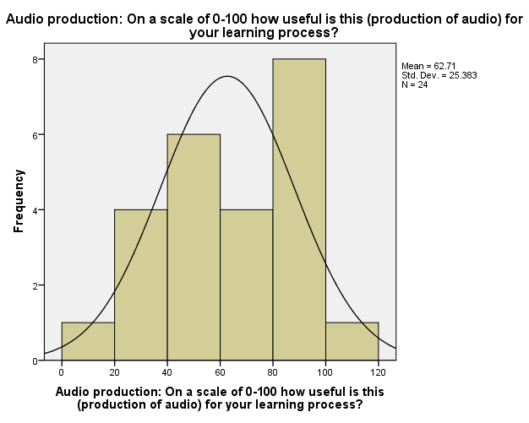

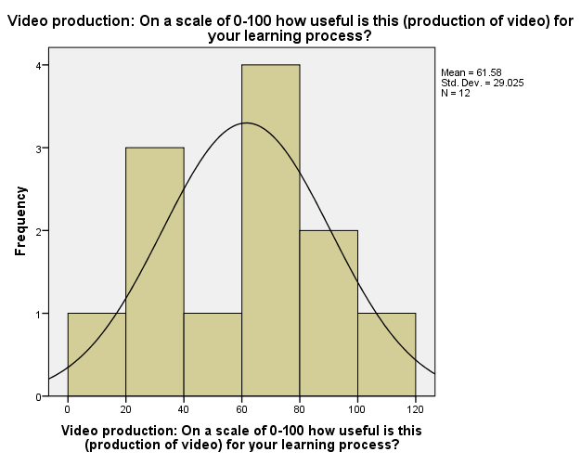

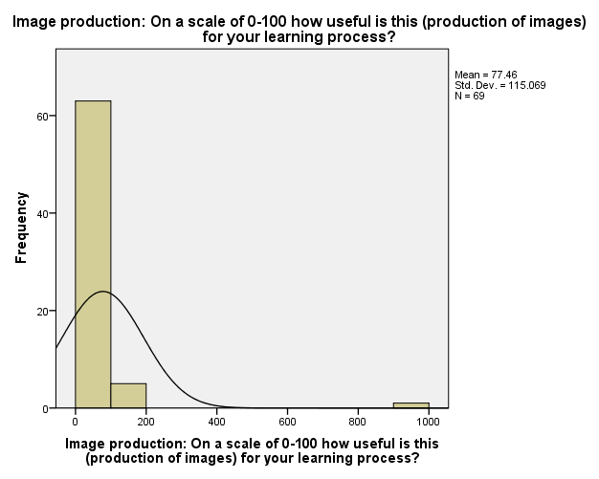

**BAR Chart**

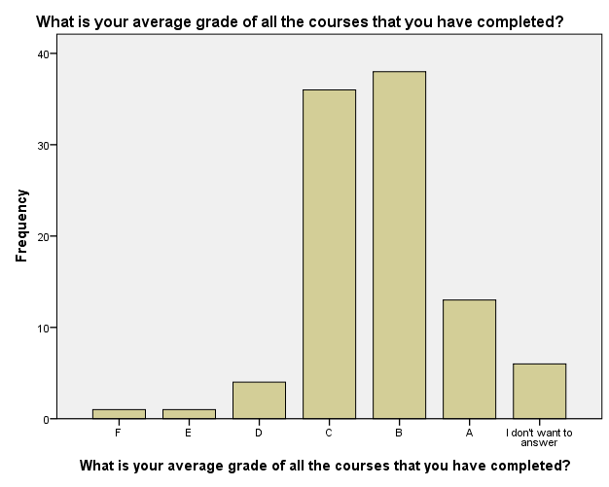

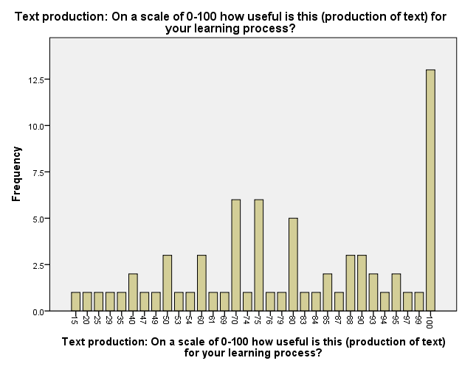

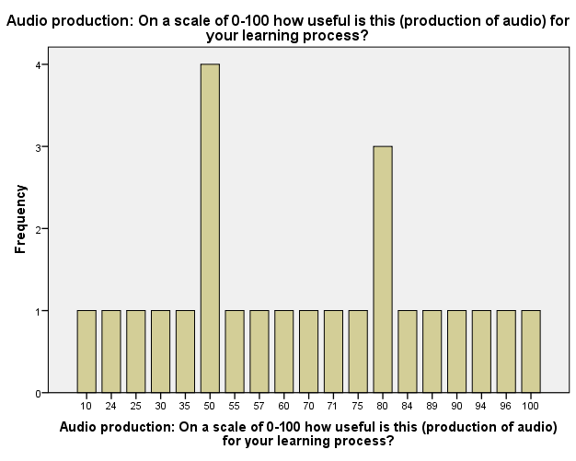

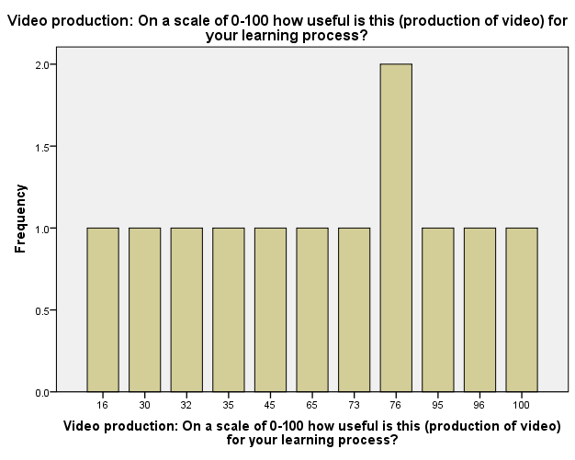

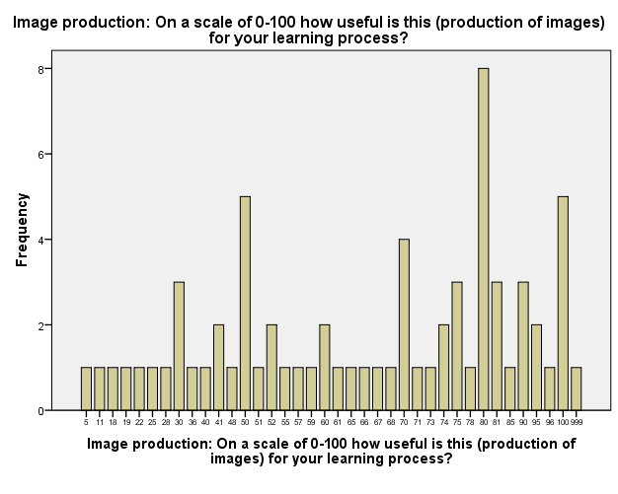

**APPENDIX C SCATTERPLOT**

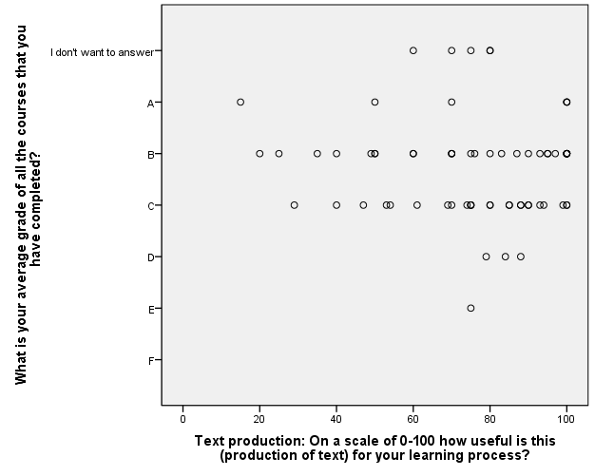

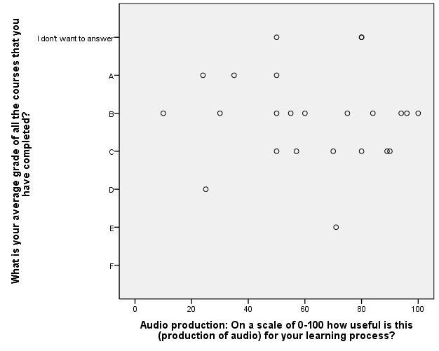

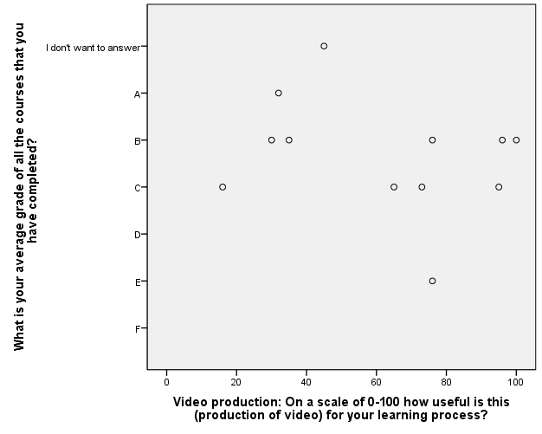

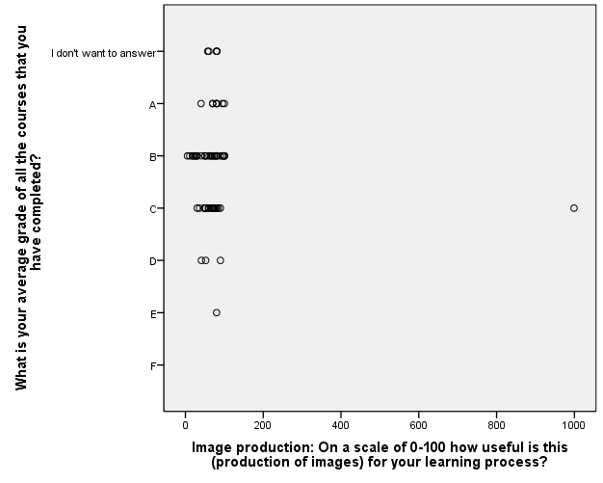

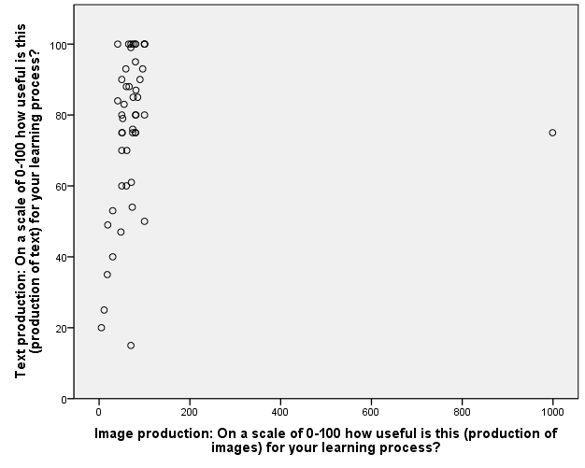

**APPENDIX D**

|  |  |  |  |
| --- | --- | --- | --- |
| **Correlations** | | | |
|  | | What is your average grade of all the courses that you have completed? | Image production: On a scale of 0-100 how useful is this (production of images) for your learning process? |
| What is your average grade of all the courses that you have completed? | Pearson Correlation | 1 | -.074 |
| Sig. (2-tailed) |  | .548 |
| N | 99 | 69 |
| Image production: On a scale of 0-100 how useful is this (production of images) for your learning process? | Pearson Correlation | -.074 | 1 |
| Sig. (2-tailed) | .548 |  |
| N | 69 | 69 |

|  |  |  |  |
| --- | --- | --- | --- |
| **Chi-Square Tests** | | | |
|  | Value | df | Asymptotic Significance (2-sided) |
| Pearson Chi-Square | 135.106a | 185 | .998 |
| Likelihood Ratio | 112.943 | 185 | 1.000 |
| Linear-by-Linear Association | .368 | 1 | .544 |
| N of Valid Cases | 69 |  |  |

a. 228 cells (100.0%) have expected count less than 5. The minimum expected count is .01.

**APPENDIX E**

**APPENDIX F**

**APPENDIX G**

.